Grade One

Young Naturalists

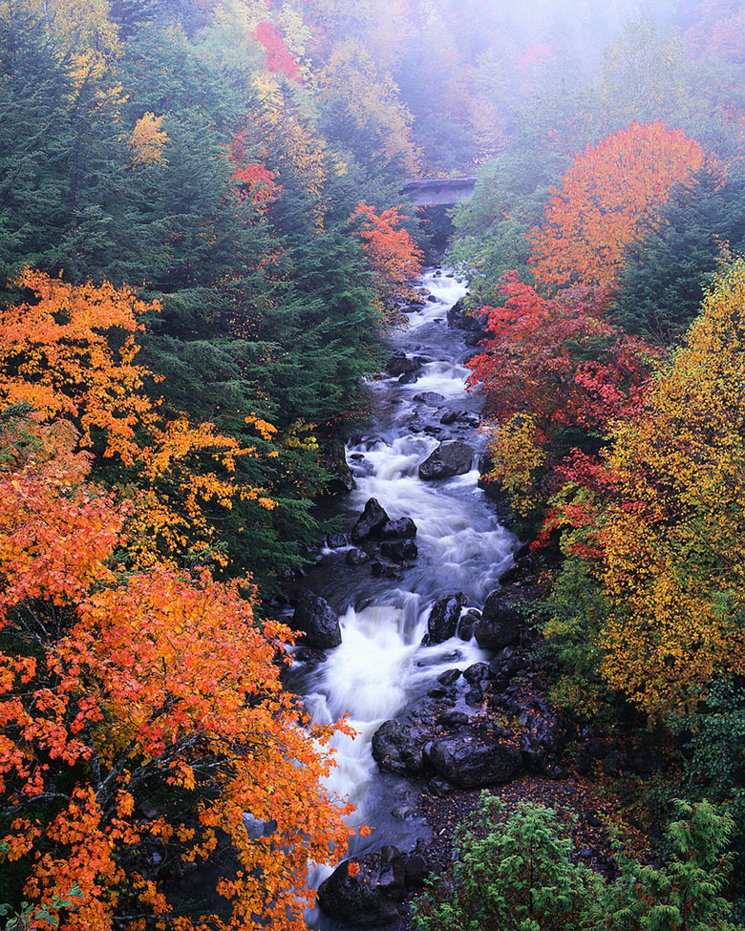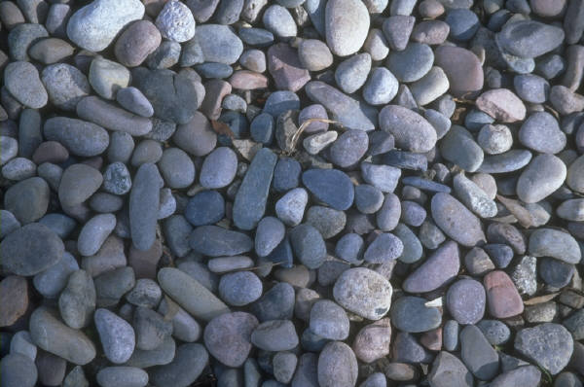
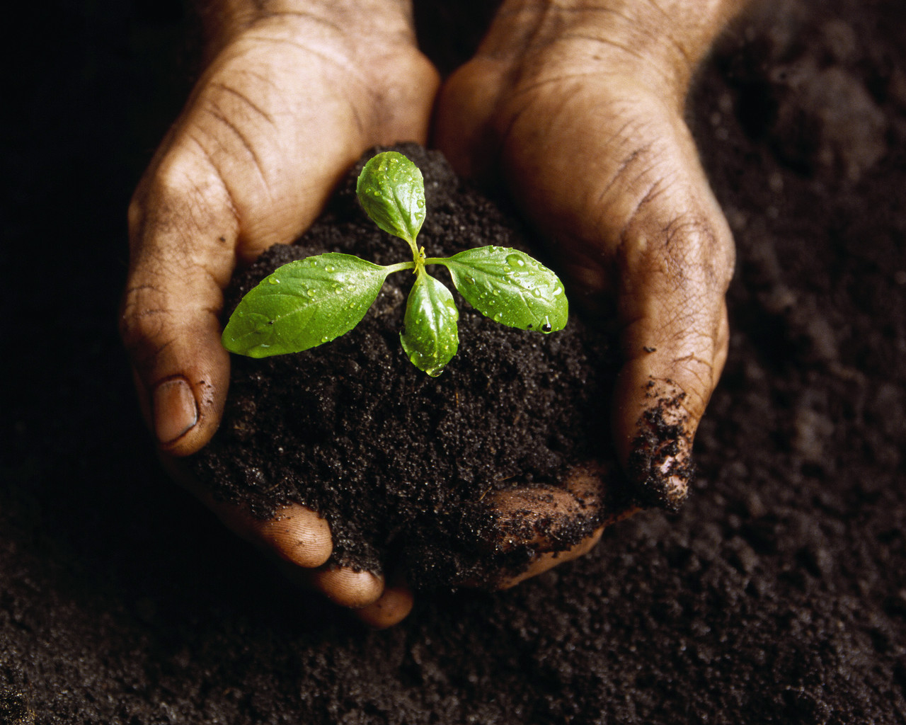

In first grade, students should develop the skills of asking questions, gathering information, and making measurements. Through observing and describing a variety of rocks and identifying how these natural resources are used, students will learn how to be young naturalists.

Young Naturalists Teaching Guide Grade 1

Overview of Learning Experiences

TEKS | - The student knows that the natural world includes rock, soil, and water. The student is expected to:  - observe and describe differences in rocks and soil samples; and
Engage | Students will go on a rock hunt to find various types of rocks in the local school area.
Explore | Students will identify different properties of their rocks through a series of investigations.
Explain | Students will observe and identify the three types of rocks.
Elaborate | Students will choose one rock from their collection and will create a “Pet Rock.” In addition, students will write a creative story about where there rock came from.
Evaluate | Students will present their pet rock and story to the class.

Young Naturalists Teaching Guide Grade 1

Targeted Texas Essential Knowledge and Skills

Science TEKS
1.1 The student conducts classroom and field investigations following home and school safety procedures. The student is expected to:
(A) demonstrate safe practices during classroom and field investigations.

1.2 The student develops abilities necessary to do scientific inquiry in the field and the classroom. The student is expected to:
(A) ask questions about organisms, objects, and events;
(B) plan and conduct simple descriptive investigations;
(C) gather information using simple equipment and tools to extend the senses;
(D) construct reasonable explanations and draw conclusion;
(E) communicate explanations about investigations.

1.3 The student knows that information and critical thinking are used in making decisions. The student is expected to:
(A) make decisions using information;
(B) discuss and justify the merits of decisions.

1.4 The student uses age-appropriate tools and models to verify that organisms and objects and parts of organisms and objects can be observed, described, and measured. The student is expected to:
(A) collect information using tools including hand lenses, clocks, computers, thermometers, and balances;
(B) record and compare collected information.

1.5 The student knows that organisms, objects, and events have properties and patterns. The student is expected to:
(A) sort objects and events based on properties and patterns.

  - The student knows that the natural world includes rock, soil, and water. The student is expected to:
- observe and describe differences in rocks and soil samples; and

Language Arts TEKS
1.1 Listening/speaking/purposes. The student listens attentively and engages in a variety of oral language experiences. The student is expected to:
(A) determine the purpose(s) for listening such as to get information, to solve problems, and to enjoy and appreciate.
(C) participate in rhymes, songs, conversations, and discussions
(D) listen critically to interpret and evaluate

1.4 Listening/speaking/communication. The student communicates clearly by putting thoughts and feelings into spoken words. The student is expected to:
(B) use vocabulary to describe clearly ideas, feelings, and experiences
(C) clarify and support spoken messages using appropriate props such as objects, pictures, and props
(D) retell a spoken message by summarizing or clarifying

1.11 Reading/vocabulary development. The student develops an extensive vocabulary. The student is expected to:
(A) discuss meanings of words and develop vocabulary through meaningful/concrete experiences.

1.15 Reading/inquiry/research. The student generates questions and conducts research about topics using information from a variety of sources, including selections read aloud. The student is expected to:
(B) uses pictures, print, and people to gather information and answer questions
(C) draw conclusions from information gathered

1.18 Writing/purposes. The student writes for a variety of audiences and purposes and in a variety of forms. The student is expected to:
(B) write labels, notes, and captions for illustrations, possessions, charts, and centers
(C) write to record ideas and reflections

1.23 Writing/inquiry/research. The student uses writing as a tool for learning and
research. The student is expected to:
(B) record or dictate his/her own knowledge of a topic in various ways such as by drawing pictures, making lists, and showing connections among ideas

Mathematics TEKS

1.9 Probability and statistics. The student displays data in an organized form. The student is expected to:
(A) collect and sort data

1.11 Underlying processes and mathematical tools. The student applies Grade 1
mathematics to solve problems connected to everyday experiences and activities in and outside of school. The student is expected to:
- use tools such as real objects, manipulatives, and technology to solve problems.

 Social Studies TEKS
1.3 History. The student understands the concepts of time and chronology. The student is expected to:
(A) distinguish among past, present, and future

Art TEKS
1.1 Perception. The student develops and organizes ideas from the environment. The student is expected to:
(A) identify similarities, differences, and variations among subjects, using the senses
(B) identify color, texture, form, line, and emphasis in nature and in the human made environment

1.2 Creative expression/performance. The student expresses ideas through original artworks, using a variety of media with appropriate skill. The student is expected to:
(C) increase manipulative skills, using a variety of materials to produce drawings, paintings, prints, constructions.

 Music TEKS

1.2 Creative expression/performance. The student performs a varied repertoire of music. The student is expected to:
(A) sing or play a classroom instrument independently or in groups; and
(B) sing songs from diverse cultures and styles or play such songs on a musical instrument.

Young Naturalists Teaching Guide Grade 1

Interdisciplinary Connections

Music

Learns and sings songs
Art

Creation of artwork
Social Studies

Concept of location
Mathematics

Collects and organizes data, communicates observations
Language Arts
listening and speaking, vocabulary, reading, writing
Properties of
Rocks and Soil

Teacher Background Information Grade 1

For young children, our world is a playground waiting to be discovered. Children have the natural tendency to pick up a rock, dig in the soil, or wiggle their toes in a stream. These experiences spark curiosity and interest about the natural world. Observing and describing the properties of rocks, soil, and water in the science classroom will be of interest to children of this age.

What makes a rock?

Rocks are naturally occurring solid matter that is made of minerals. Minerals are also naturally occurring and are solid crystalline substances that are made-up of specific chemical compositions.
Rocks are forming all of the time and can be classified in different ways. A rock is not alive or was never alive. Rocks go through cycles and can be classified as igneous, metamorphic, or sedimentary.

Igneous rock is derived from magma. Magma is a very hot, thick fluid that contains solids and gases. The solids are mineral crystals. It also contains liquids that are composed of ions that move freely. As the magma cools, the movements of the ions slow, and the ions begin to arrange themselves into orderly patterns. This process is called crystallization. This solidifying process does not occur at the same time. As the magma begins to cool, small crystals develop. Slow cooling results in the formation of large crystals. The magma located deep in the earth cools very slowly and will eventually crystallize at depth. These rocks are called intrusive.
Igneous rocks can also be formed from lava. Lava is similar to magma, except most of the gases have escaped. Lava flows on the surface of the earth. Rocks that form from lava have a very fine-grained texture with the individual crystals too small to be seen with an unaided eye. These rocks are called extrusive.

Metamorphic rock is formed by heat and pressure under the earth’s crust. Changes involved in the metamorphism occur in the solid state. During low-grade metamorphism, rocks are subjected to temperatures and pressures only slightly greater than those associated with compaction that lithifies the sediments. Under more extreme conditions, pressure causes certain minerals to recrystallize with a preferred orientation. This resulting alignment gives the rock a layered or banded appearance we call foliated. Not all metamorphic rocks have a foliated texture. Some rocks exhibit a nonfoliated texture. The rocks that are composed of only one-mineral and forms equidimensional crystals are not visibly foliated. They are said to have a non-foliated texture. For example, limestone, if pure, is only one mineral, calcite. Marble, a metamorphic rock, was once a sedimentary rock called limestone.

Sedimentary rocks are created by erosion and weathering. Sedimentary is derived from the Latin word sedimentum, which means, “settling”. As sediments (sand, mud, and shells) are carried to new places by water, ice and wind, they become deposited in lakes, river valleys, and seas. As the sediments accumulate, they become compacted by the weight of the overlying layers. Over thousands of years these sediments are cemented together by mineral matter deposited from water in the spaces between the particles. This forms solid sedimentary rock.
Some sedimentary rocks also form from chemical precipitation from water. These materials do not remain dissolved in the water indefinitely. When the conditions are just right, it will precipitate to form chemical sediments. Limestone is one of the most abundant chemical sedimentary rocks. Ninety percent of limestone is a bio-chemical sediment. The rest precipitates directly from water. Sedimentary rocks and their minerals are used for many things such as buildings, cars, sidewalks, and toothpaste.

What is soil?

Soil is a combination of pieces of rock, organic material, air and water. It is mainly defined by its texture, color, water-holding capacity, and drainage. The color of soil gives clues to its health, origin, and long-term changes. Texture tells what it is made up of: sand, silt, or clay. Drainage refers to the soil’s ability to drain excess water. Water-holding capacity refers to the soil’s ability to hold water. Scientists also look at depth, tilth (the condition of the land in terms of its cultivation history and suitability for crops), and slope of the soil.

What’s in water?

Water is essential for the existence of life on Earth. It is found underground, on mountaintops, in our air, and it is what makes up over 75% of earth. Water is liquid matter that can be in the form of a solid, ice, or an invisible gas such as water vapor. It goes through the processes of evaporation, condensation, and precipitation in a cycle. Water is classified as a renewable resource because of its capacity to be replaced as it is used. Water is a chemical compound and can be written as H₂O.

Young Naturalists Teaching Guide Grade 1

Engage

1. Let’s go on a rock hunt! Before class, find a good area around your school where students can easily find rocks. A local creek or an area with less vegetation would be ideal.

2. Read the book, Everybody Needs a Rock by Byrd Baylor. This book describes how to find a special rock.

2. Distribute a plastic baggie to each student. Explain to them that they are going to go on a rock collecting hunt. Challenge them to find at least three rocks.

3. After collecting their rocks, have students label a plastic plate with their name. Then have them put their three rocks on the plate to get ready for the next activity.
Materials:

- Plastic bag for each student
- Plastic plate for each student
- Everybody Needs a Rock, by Byrd Baylor

Young Naturalists Teaching Guide Grade 1

Explore

Using the three rocks from the collection in the engage activity, have students perform a variety of tests on each one. Use the chart and the materials listed.

What Can My Rocks Do?
 | Does it fizz? | Sink or Float? | What color(s) is it? | Can I draw with it?
Rock # 1
Rock # 2
Rock # 3

1. For “Does it Fizz?” have students use a dropper to place hydrochloric acid on their rock. If it fizzes, then calcite is present.

2. For “Sink or Float?” have students place their rock in a bowl or tub of water. Have them right the word sink or the word float in the chart.

3. For “What color is it?” have students write the color or colors of their rock. They can also use different colors of crayon to show the colors.

4. For “Can I write with it?” have students make a streak on a black piece of paper to see if their rock makes a mark. If it does, have them write yes on the chart, if it doesn’t, have them write no.

Materials:

- Dropper or pipette for each student
- Hydrochloric acid (vinegar can be used as a substitute)
- Bowl of water
- A set of crayons
- Safety goggles
- Student page

Safety First! Remind students to wear their
Safety goggles for this activity.
Hydrochloric acid or vinegar is corrosive.

Name_________________________
Young Naturalists student page Grade 1

What Can My Rocks Do?
 | Does it fizz? | Sink or Float? | What color(s) is it? | Can I draw with it?
Rock # 1
Rock # 2
Rock # 3

Young Naturalists Teaching Guide Grade 1

Explain

Read the book, Stonewall Secrets, by Kristine and Robert M. Thorson. Explain to students that many stones “tell a story” because they were made in different ways and are composed of different minerals or particles. They give us clues about the past and about how the Earth behaves. The stones the students collected from their rock hunt may have looked and did things differently from one another just like the stones from the story.

Distribute the Texas Rock Kits and magnifiers to each group of students. Allow adequate time for students to observe the rocks.

Explain to students that rocks can be classified into three different categories: igneous, sedimentary, and metamorphic. Igneous rocks are formed from volcanoes and magma, metamorphic rock is formed from heat and pressure inside the Earth, and sedimentary rock is formed fro tiny particles being cemented over a long period of time. Each of these three types of rock are in the kits they observed and they can all be found in Texas. Teach students the following song to help them remember the differences between the different types of rock.

To the tune of “Mary Had a Little Lamb”
Materials:

- 1 Texas Rock Kit for each group of students
- Song written on chart paper
- Magnifiers
- Stonewall Secrets by Kristine and Robert M. Thorson

There was once an igneous rock
Formed from lava from a volcano.
There was once an igneous rock
Made from cooled down lava

Then there was metamorphic rock
Formed from heat and pressure
Inside the Earth
Then there was metamorphic rock
That hardened over time

Finally there’s sedimentary rock
That has a lot of layers
Because of the small pieces
Finally there’s sedimentary rock
That took a while to cement

Young Naturalists Teaching Guide Grade 1

Elaborate

Tell the children that they will make a pet rock with one of the rocks from their collections and will write a story about it.

Distribute paint, brushes, and self-stick googley eyes to each student. Instruct them to paint their chosen rock and when it is dry, place two eyes on it.

They should name their rock and write a story about where it came from and the journeys it may have taken. Remind students of the stones from the story, Stonewall Secrets. They may also use information that they gathered about their rock from the Explore section.

Materials:

- For each student - 1 rock chosen from their collection
- Tempera paint
- Paint brushes
- Self-stick googley eyes
- Writing paper

Grade 1 Evaluate

Evaluate

- Student will read a loud their stories and present their pet rock to the class.

- When all students are done sharing their pet rocks and stories, discuss ways to they can make a home for their pet rocks. A few suggestions are:
  - Make a class garden using a large tray and potting soil
  - Decorate a shoebox
  - Create a terrarium with plants, soil, and other natural objects

- Then have students design and create a home for their pet rock.

- Use the rubric to evaluate their final product. See rubric on the following page.

Name: _____________________
Project Title: _____________________ | Teacher(s):
Date: ___________________

My Pet Rock

Process | Below Avg. | Satisfactory | Excellent
1. Has clear vision of final product | 1, 2, 3 | 4, 5, 6 | 7, 8, 9
2. Properly organized to complete project | 1, 2, 3 | 4, 5, 6 | 7, 8, 9
3. Managed time wisely | 1, 2, 3 | 4, 5, 6 | 7, 8, 9
4. Acquired needed knowledge base | 1, 2, 3 | 4, 5, 6 | 7, 8, 9
5. Communicated efforts with teacher | 1, 2, 3 | 4, 5, 6 | 7, 8, 9

Product (Project) | Below Avg. | Satisfactory | Excellent
1. Format | 1, 2, 3 | 4, 5, 6 | 7, 8, 9
2. Mechanics of speaking/writing | 1, 2, 3 | 4, 5, 6 | 7, 8, 9
3. Organization and structure | 1, 2, 3 | 4, 5, 6 | 7, 8, 9
4. Creativity | 1, 2, 3 | 4, 5, 6 | 7, 8, 9
5. Demonstrates knowledge | 1, 2, 3 | 4, 5, 6 | 7, 8, 9, 10
6. Other: | 1, 2, 3 | 4, 5, 6 | 7, 8, 9

Total Score:____________________________
Teacher(s) Comments:

Powered by TeAch-nology.com- The Web Portal For Educators! (www.teach-nology.com)

Young Naturalists Teaching Guide Grade 1

Reading Connections

Everybody Needs a Rock Byrd Baylor, Aladdin Books, 1974.
Everybody needs to have a special rock. This book lists ten rules for finding the rock you need. Black-line sketches are highlighted with soft brown tones. This selection provides a useful connection to units on geology, rocks, and soil.

Stone Soup Marcia Brown, Simon and Schuster, 1987.
When three hungry soldiers come to a town where all the food has been hidden, they set out to make soup of water and stones, and all the town enjoys a feast.

The Boy on the Beach Niki Daly. Margaret McElderry Publications, 1999.
A summertime outing at the seashore finds a young African American boy exploring the beach and having an imaginary adventure in a deserted boat. Casual rhymes highlight watercolor illustrations that show the vibrant colors of the busy beach on a bright summer day.

The Big Rock Bruce Hiscock. Atheneum, 1988.
This concept book tells how a large granite rock in the forest came to be and its changes over time. Geological terms are explained and can be enhanced with teacher support. Full-page, realistic illustrations help to clarify the story.

Desert Trip Barbara A. Steiner. Sierra Club Book, 1996.
A young girl and her mother backpack in the desert and learn about the plants, animals, birds, and rock formations. Soft watercolor illustrations and first-person narrative capture the magic of the desert and bring the reader/listener into the backpackers' adventure of discovery.

Welcome to the Sea of Sand Jane Yolen . Putnam Publishing, 1996.
In this book, the Sonoran Desert is described in lively verse, with waves of sand, cactus, and a great and gorgeous variety of animals. Gouache paintings capture the life of this unique landscape. This selection is useful for exploring various adaptations and habitats.

Sylvester and the Magic Pebble William Steig. Simon and Shuster, 1988.
A young donkey finds a magic pebble that grants him three wishes. When frightened by a lion, the donkey wishes he were a rock. His wish is granted, but the rock is too far away from the magic pebble to undo the wish after the danger has passed. Use this book to encourage readers to speculate what they would wish for if they were granted three wishes.

Stone Wall Secrets Kristine Thorson, Robert M. Thorson, Gustav Moore. Tilbury House Publishers, 1998.
An old man shares stories about the geologic history of the stones that kine his New England farm’s wall as well as some of the memories they hold for him.

*All annotations are from The California Department of Education Curriculum Resource Center.

Young Naturalists Teaching Guide Grade 1

References

Rocks and Minerals. National Geographic Society, Washington D.C., 2004.

Rocks and Minerals. Dorling Kindersley, New York, 2004.

Rock Cycle: Understanding the Earth’s Crust Activities and Lesson Plans,
California, 1988.

Texas Rock Kit can be ordered from:
www.beg.utexas.edu/education/nw_online-mod.htm
1-888-839-4365

Web Resources:

www.rockhounds.com

www.agintheclassroom.org

